
Land Information Ontario (LIO) Warehouse
Data Class Name: Wilderness Area
Documentation
Produced by: Information Access and Information Management Policy Unit
Ministry of Natural Resources and Forestry
Date: July 27, 2015

Purpose

This document provides additional information to support the use of geospatial data. The Physical Model Diagram provides a visual representation of the relationships in the data class. The Data Change History lists all the modelling and access changes that have occurred during the lifecycle of the data class. A data description identifying table and field names is available upon request.

Need Assistance?
Please contact LIO Support at lio@ontario.ca or 705-755-1878 if you require help.

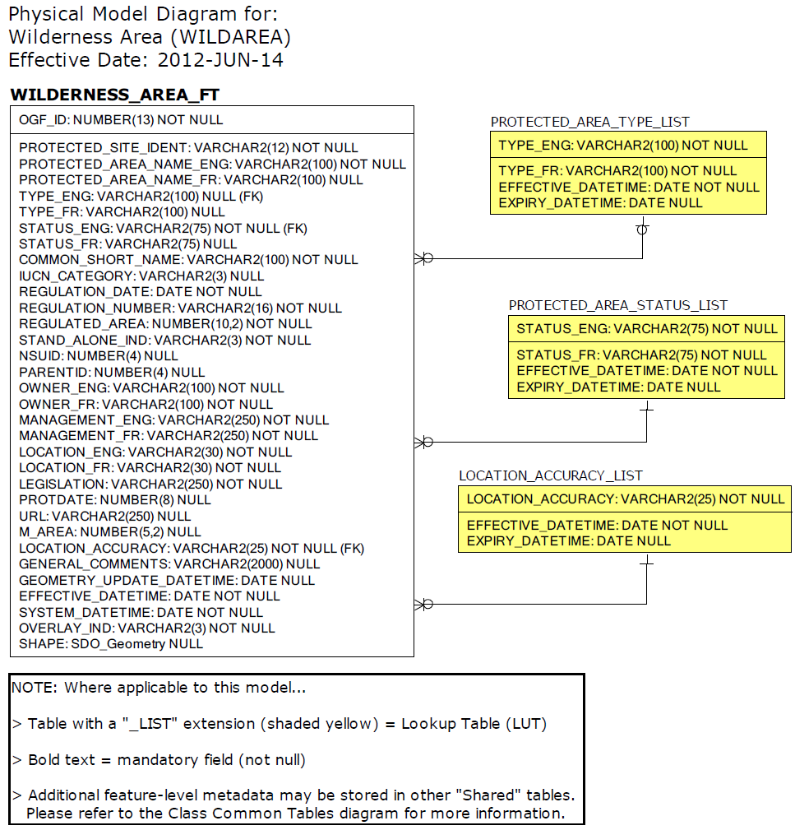

Data Class Change History

Data Class Name: Wilderness Area
Data Class Short Name: WILDAREA
Date  YYYY-MM-DD | Details of Change
2012 | Added OVERLAY_IND (Overlay Indicator) to main table.
2006 | Table Changed: WILDERNESS_AREA-  Added the following Columns: National Schema ID, Parent ID, Ownership English/French, Management English/French, Location English/French, Legislation, Protection Date, URL and Marine Area.
2006 | Table Added: WILDERNESS_AREA-  Type Designation lookup table replaces Protected Area Type.
2006 | Table Added: WILDERNESS_AREA-  Status Description lookup table added.
2003 | NEW Data Class: Implementation Note - the Stand Alone Indicator eliminates the need to do a spatial overlay every time Ontario Parks needs to do standard queries regarding the amount of protected area in the province (only those Wilderness Areas outside of parks are included for this calculation). Wilderness Areas are no longer being created/regulated.
Data Description
Please refer to the metadata record for the data description.

